Setting a User Override

Sometimes, you might need to change a quiz setting for a particular use or users because of specific circumstances. An example of this would be if a student needed extended time on a quiz.
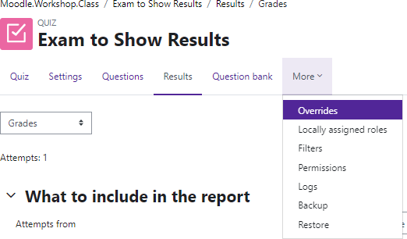
To set up a user override:
Log in to Moodle and navigate to the course. Locate and click on the quiz link.
Under the course name, click More and find Overrides.

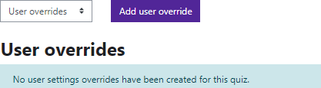
Click on Add user override.

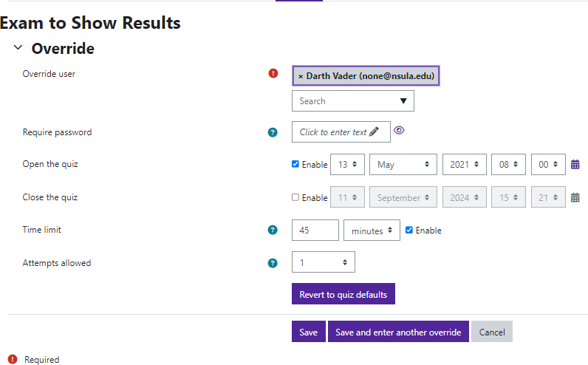
Use the dropdown menu to select the student from the list of participants.
There are several options for overrides including:
- Require password
- Quiz open & close times
- Time limit
- Attempts allowed
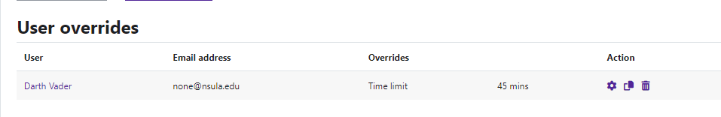
Choose the settings for this particular student. You can have multiple options selected.
Save or Save and enter another override.

Moodle v. 4.5.7 Updated 3/26

